|  |
| --- |
| Norwich University of the Arts |
| Iteration-1 GDDL |
| Game Design Document Light |

|  |
| --- |
| Samuel Russell  2-26-2019 |

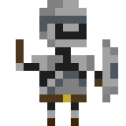

## **Overview**

*Describe the final game*

This game is a 2D dungeon crawler for mobile platforms with some rogue-like and RPG elements. The main focus of the game would be on its combat and movement, all of which can be performed with one hand as the weapon is a large sword or chain-mace that can be swung around. The dungeons will be fairly small, with several floors, enough to be completed in about half an hour with each floor taking roughly a maximum of 3 minutes. There will be rewards for killing certain enemies and defeating each level of the dungeon. These rewards can have all sorts of effects on your character and their weapon. This enhances the gameplay and makes every dungeon experience different whilst also evolving the gameplay in each dungeon.

**SETTING**

The setting is a classic adventure fantasy world with various creatures like orcs and goblins as enemies and magical effects like fire damage for your weapons. The main currency that is used for shops and as rewards for quests is gold pieces.

**DUNGEONS**

The dungeons are the areas the player will spend the most time in. It’s where all combat happens as well as the only place enemies and loot spawns. Each floor of the dungeons will be procedurally generated before the player enters so during gameplay there are no slowdowns or stops.

Dungeon Generation methods:

The generation will be based on Rogue’s. This is where the roguelike genre and the inspiration for my dungeon design comes from. Essentially the generator creates a set amount of rooms with connecting hallways, giving small narrow areas as well as wide open ones, further enhancing combat and creating a good balance in the intensity in the different areas.

Existing generation methods for creating this type of dungeon are based around placing all the rooms or halls first and then connecting or adding rooms later. However I will be using my own method similar to a random walk algorithm. Random walk describes several random steps that add up to create a path. I’m choosing to create it this way as it is lighter on resources and can be faster to generate. It also works well with how I want the player to explore the dungeons. They would ‘snake’ and fan out from a central starting room, with few links between.

**WEAPONRY and UPGRADES**

PLAYER

WEIGHT

MOVEMENT -

The weapon and combat revolve around swinging circular momentum. The weapons act like a weight on the end of a string. When you start spinning the string it applies a force on the weight, pulling it along and the weight starts spinning too. By moving in a circle in the game the weapon moves in a circle too.

The velocity of the weapon dictates how much damage will be done to enemies and the environment. Because it uses Matter physics when the weighted section hits objects it gets slowed. The weight has minimal to no effect on the player.

**HUB**

There will be a home or hub screen that lets you walk about outside of the dungeons. There are several things you can do:

* Manage and find quests – these will be simple quests that give you a small amount of gold pieces.
* Shop – buy cosmetics to change the look of your character and buy upgrades for your weapon.
* Armoury – This is where you swap out upgrades, cosmetics and what weapon type you are using.
* Explore/Map – An area where you can set what dungeon you want to go explore and takes you to the main gameplay scene.
* Settings – Where you change the settings for the game. (most likely an on screen button)

**AUDIENCE**

The audience for this is people who have time in their day to spare, want to play casual games. The audience must also have a mobile device. Because of these things the intended audience is people aged 15 to 35.

**USP**

The unique selling point is the games engaging and fun 30 second game loop; smashing enemies, getting loot and gold pieces and getting stronger, to defeat stronger enemies and so on. The physics based combat and good reward system separate this game from others. The rewards and shop in the hub keep you coming back as it changes the way the game is played.

## **Prototype Iteration 1 Objectives**

*Gameplay / what happens / what are you fundamentally solving / testing*

For the first iteration of this game I need to have something interactable and able to test to then iterate on. I would like to test the core gameplay of this game. Specifically, I would like to test how players feel about the procedural dungeons working with the gameplay; if they feel they’re right size for the players weapon and movement, if the physical interactions between the mace and walls and objects is fun or a hindrance and if they feel mysterious and fun to explore. I also want to test how long it takes people to find the ends of levels and dungeons. This would help give some quantitative insight into how complex people find the dungeons. So there are some things that need to be in place to be able to achieve this.

**Iteration 1 Goals:**

1. Player Movement – Using screen touch detection.
2. Weapon Swinging – With physics and collision detection.
3. Dungeon Generation – First iteration generation, enough to get around and explore.
4. Something to hit – This could be enemies or just a dummy.
5. Google analytics – For recording information.

Currently I have some of the basics down already, so I can focus on the generation algorithm.

**Current foundations:**

* General game setup – Phaser 3 config and separate scenes.
* Player Movement – A very basic movement that works with a vector 2 input. (animation ready too)
* Basics of swiping.
* First Mace variation – This will need a rework.
* Start Menu – This currently just has a start button.

That leaves a small list of things to do. This is the focus of my iteration task.

**Iteration 1 Tasks to do:**

* Weapon completion – Finish the weapon basics. (Sword and mace)
* Dungeon Generation – With placeholder enemies and start and finish.
* Create better start screen.
* Insert Google analytics pointers.

**Dungeon Generation Information:**

Variables:

|  |  |  |
| --- | --- | --- |
| ROOMS | HALLS | GENERAL |
| Average room width | Width | Size (general multiplier) |
| Average room height | Length | Total rooms |
| Room style |  | Starting diverging path count |
|  |  | Loot percentage |

Generation Origin

Exit at arm end

Loot at arm end

## **Tech Architecture**

*Platform, API’s, Libraries etc*

I will be using the Phaser 3 game framework for JavaScript in browser games. Inside Phaser 3 I will be using the matter.js 2d game engine as it allows for constraints and custom polygon shapes. I won’t be using any other API’s or Libraries. The intended platform is mobile, and as a secondary target tablets and other touchscreen devices. I will not be adding scaling to screen in the first iteration.

## **UI and UX**

*Control mechanism*

The controls will use a simple joystick style swipe. It will take the initial position of the pointer as the centre of the joystick so the user can choose where is most comfortable for them.

*Wireframe*

*Feedback*

For feedback I will be using sound and visual effects. For instance the camera will shake when the player gets hit and a sound will be played to signify that the player has taken damage.

## **Visual Design**

I want the visual design to follow a retro feel. Using 8-bit pixel-art graphics with a bright colour palate, similar to ‘Legend of Zelda-Links Awakening’, or like the more modern ‘Enter the Gungeon’.

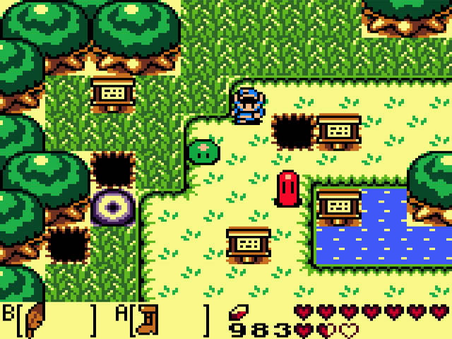

Link’s Awakening Over-world

I will be creating these assets myself as I want to make sure the feel of the graphics is right. But I will only be creating some temporary assets in this slice. I will most likely for testing in iteration one use very simplistic sprites that are the right size for testing and are detailed enough that the player can infer what it is.

## **Audio**

It is unlikely that there will be any sound at this stage, it is not necessary for my testing.

## **Planning**

*Approach to build, e.g. prioritising x over y*

*Speculative planning for weeks 21 and 22*

*Mon PM*

*Tues AM, PM*

*Weds AM*

*Thurs PM*

## **Testing**

*Describe the testing methodology you intend to employ to test Iteration 1*

I will be doing most quantitative and qualitative testing to get actual opinions on subjective matters as well as data on the more technical matters.

**QUANTITATIVE**

Something I need to measure is the time it takes people to explore the dungeon, and a percentage of the dungeon they explored. This would help with keeping the length and complexity of these dungeons in an acceptable bracket.

**QUALITATIVE**

I also want to know what people think of exploring the dungeon. If people hate it then something needs to change. Asking the right questions will help discover what.